IT INSTITUTE DATABASE

INTRODUCTION

The purpose of our project is to store all the information regarding COURSES, STUDENTS, TEACHERS in an institute, so that all the information can be managed by the administrator.

Managing the information includes adding new data or editing the existing data or just viewing the stored data easily without any errors using RDBMS.

Our database includes table-

1.Courses- Includes course id, course name, duration and fees.

2.Student- Includes student id, course id, Name, phoneno, email, age, city and their qualification

3.Teachers-Includes id, name, qualification, phone, courseid they teach.

4.Admin_master-Includes courseid, studentid, date of enrollment, grade of student, fee status of students.

# ER DIAGRAM

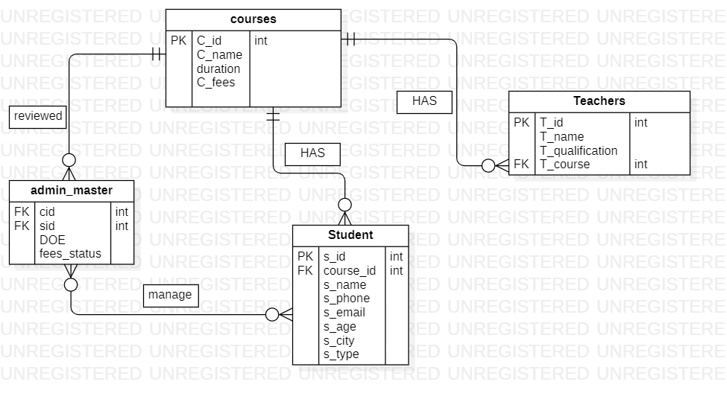

# DATABASE DESIGN

**Database:IT_INSTITUTE**

**TABLES:1. Courses**

**2. Teachers**

**3. Student**

**4. Admin_master**

# DDL QUERIES

**Creating database and tables:**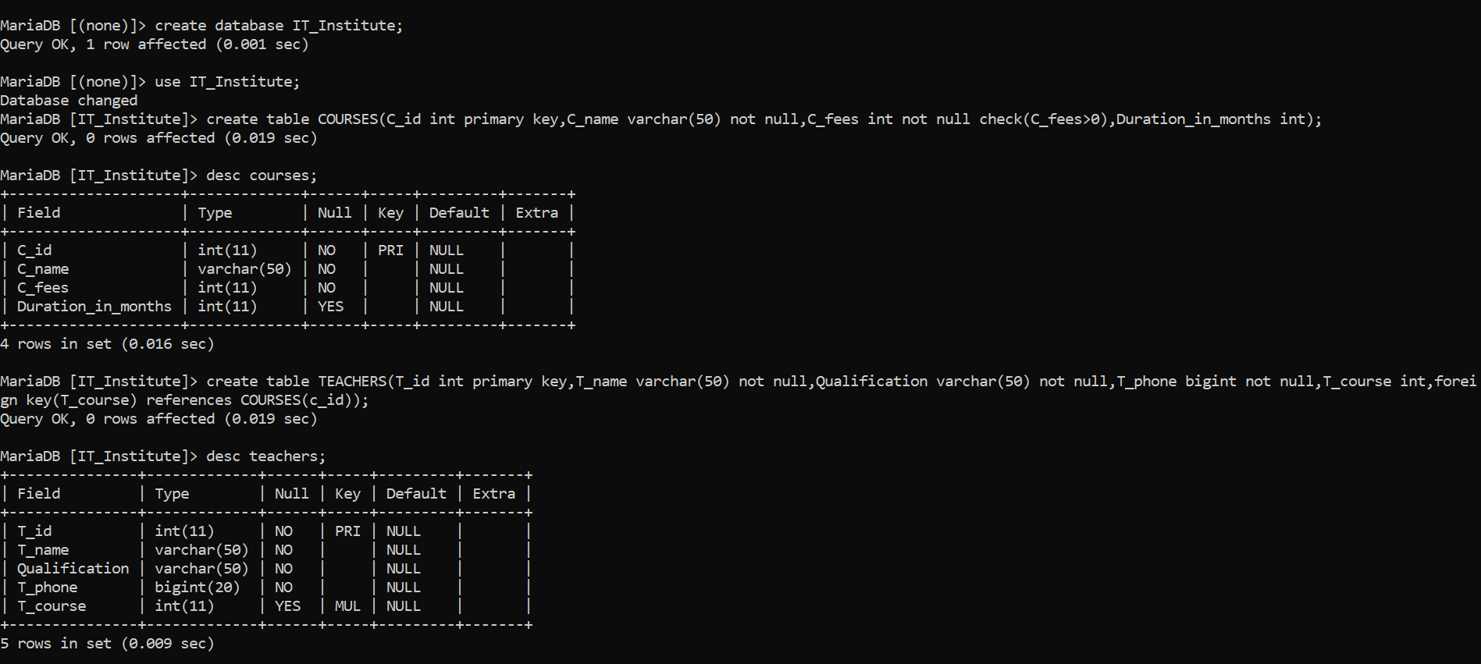

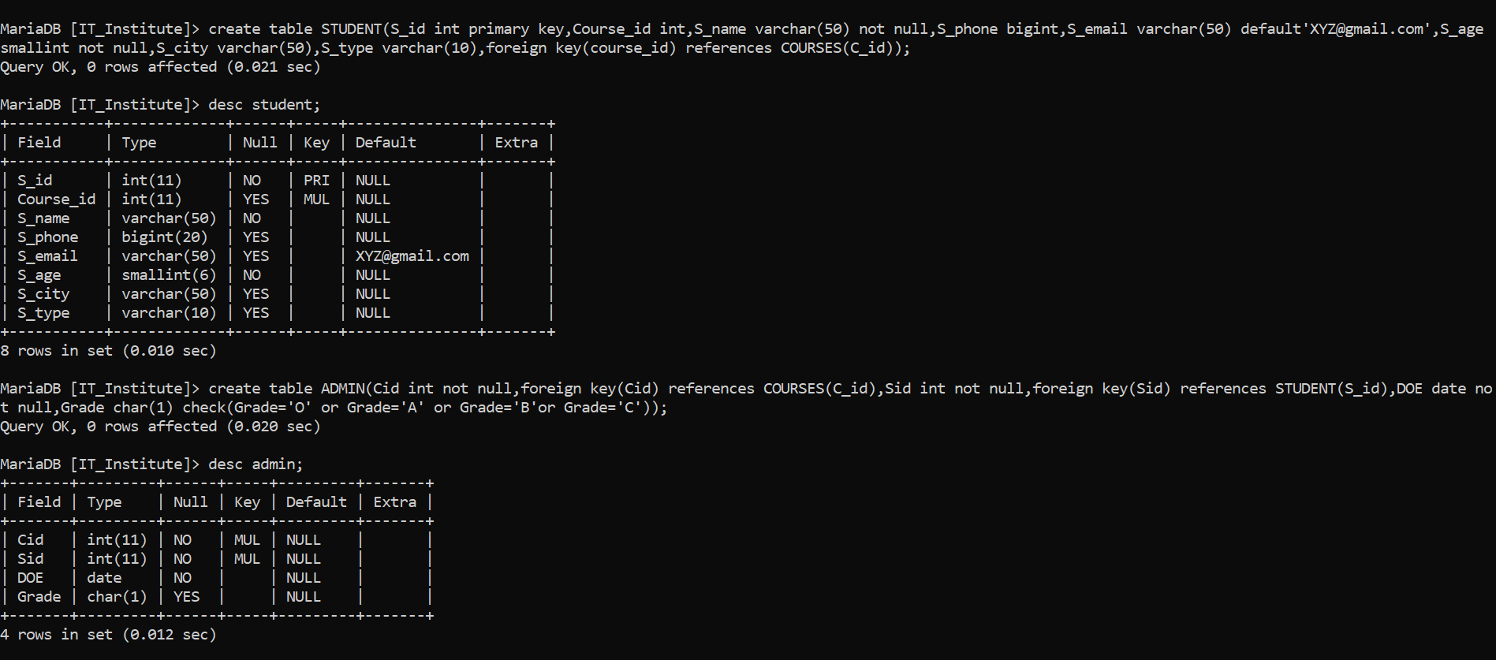

**Alter queries:**

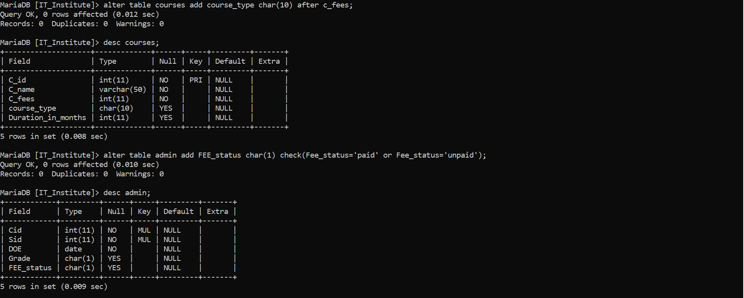

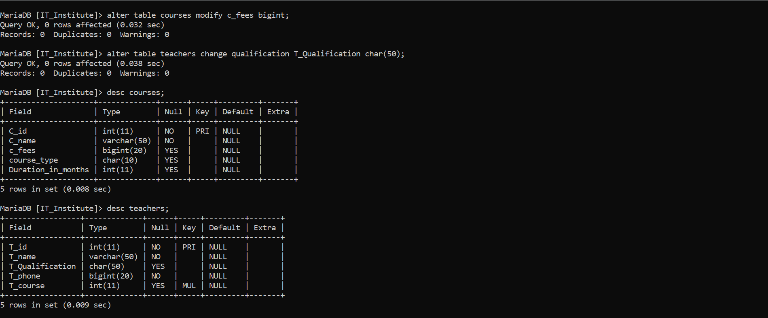

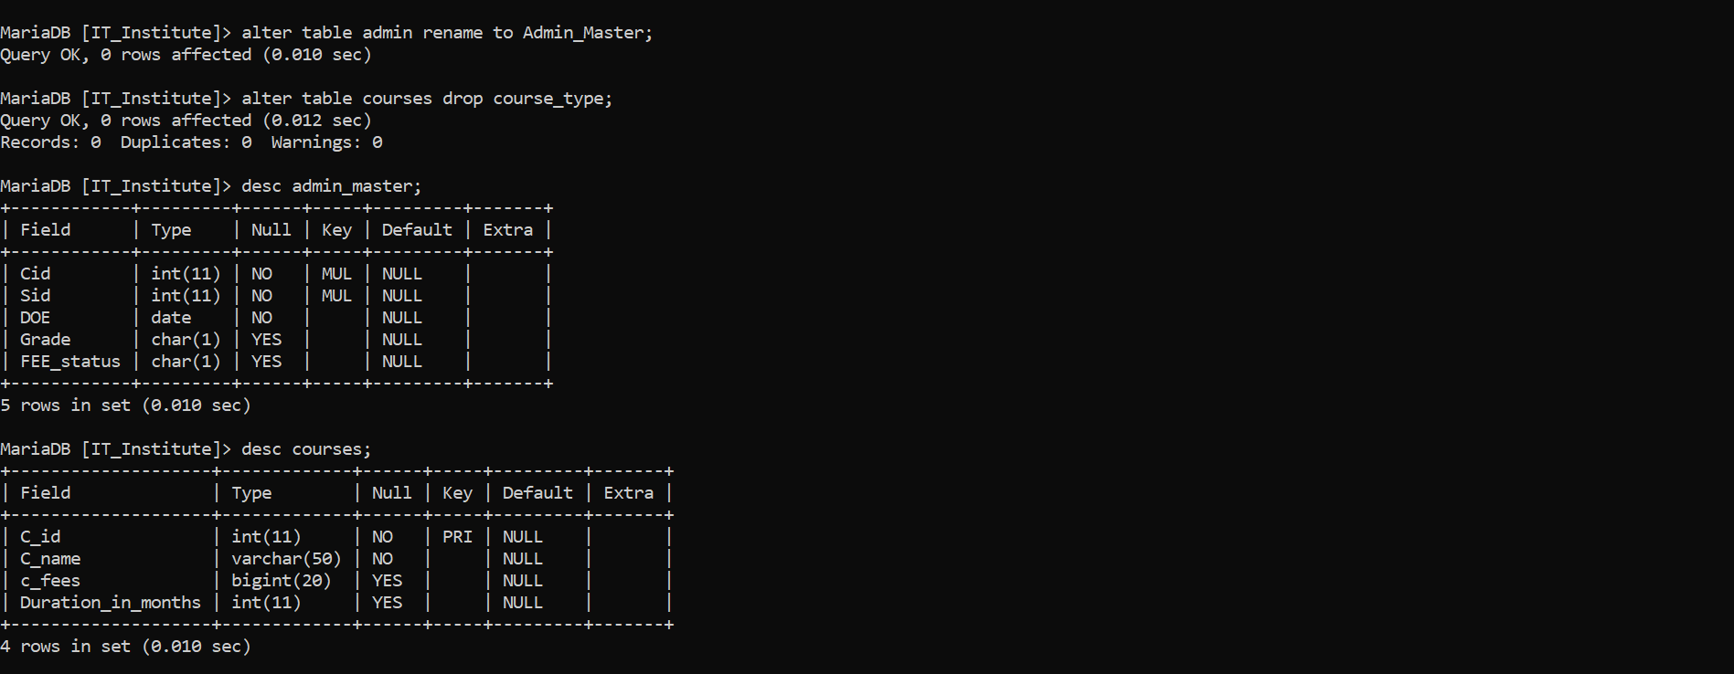

# DML QUERIES

**Insert queries:**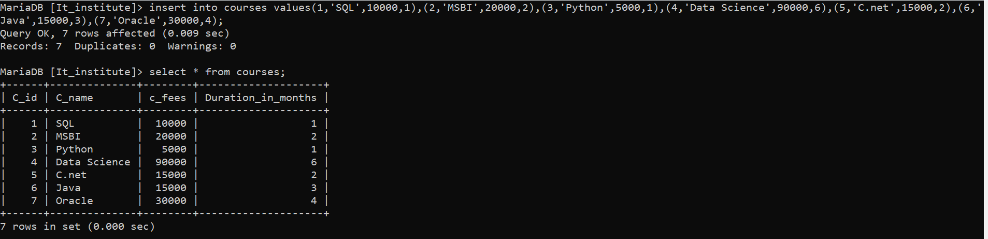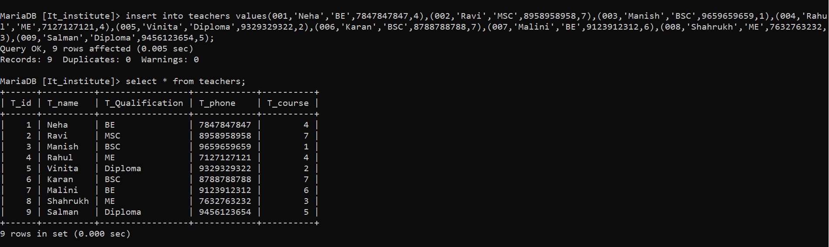

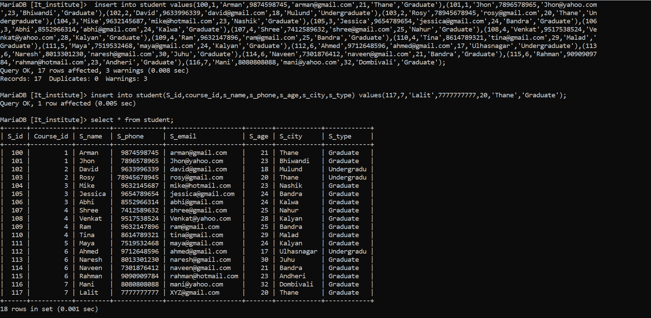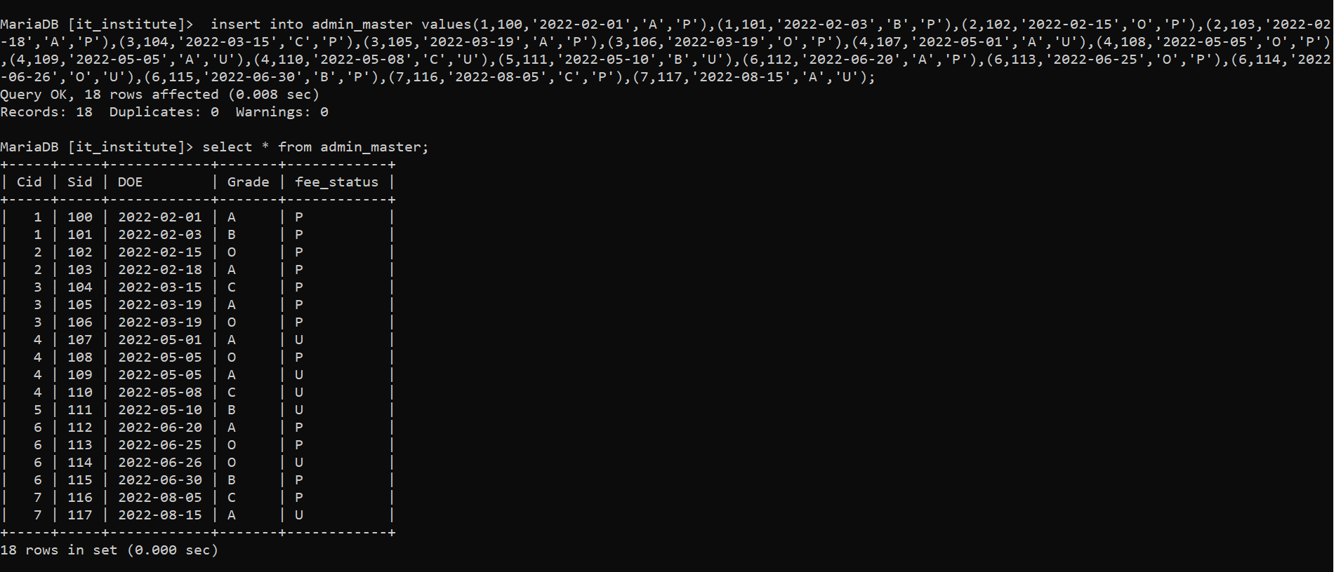

**Update queries:**

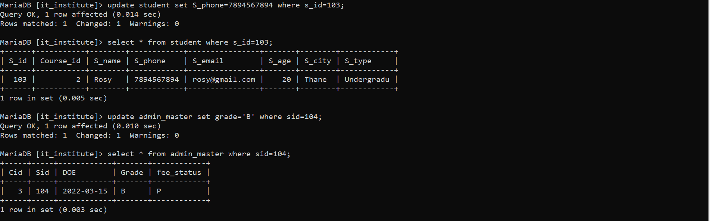

# DQL QUERIES

**Select queries and Sorting with WHERE clause:**

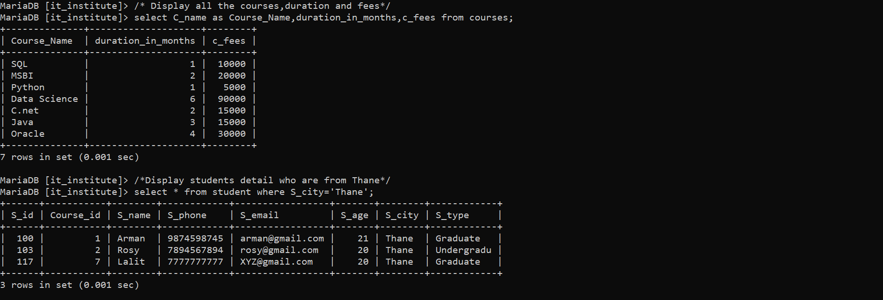

**Select queries with Logical operators:**

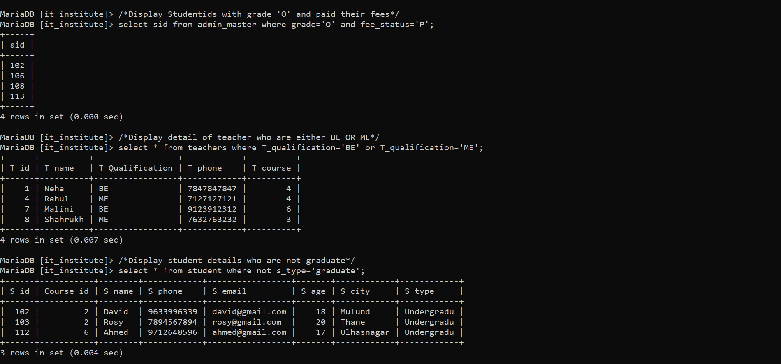**Select queries with Between and In operators:**

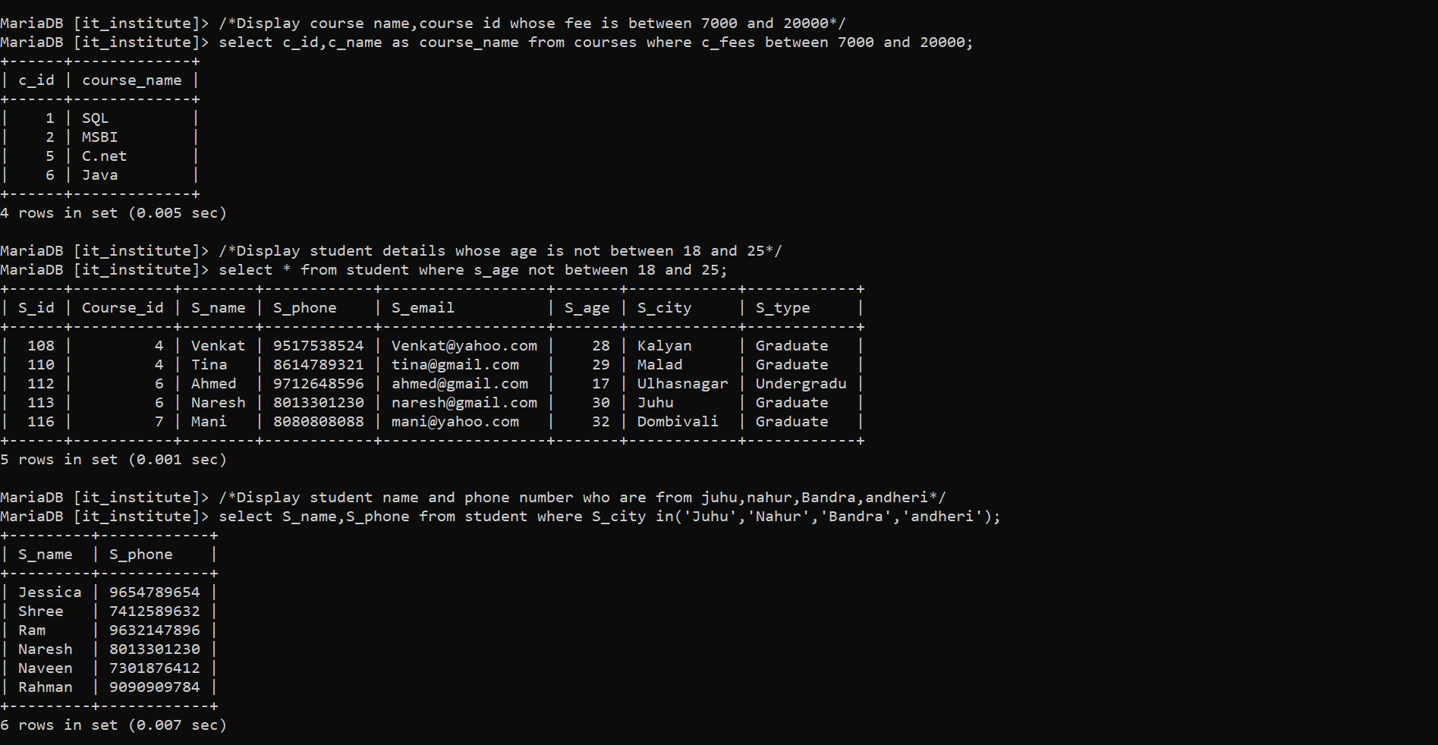

**Select queries with Like operator, Limit clause and Order by clause:**

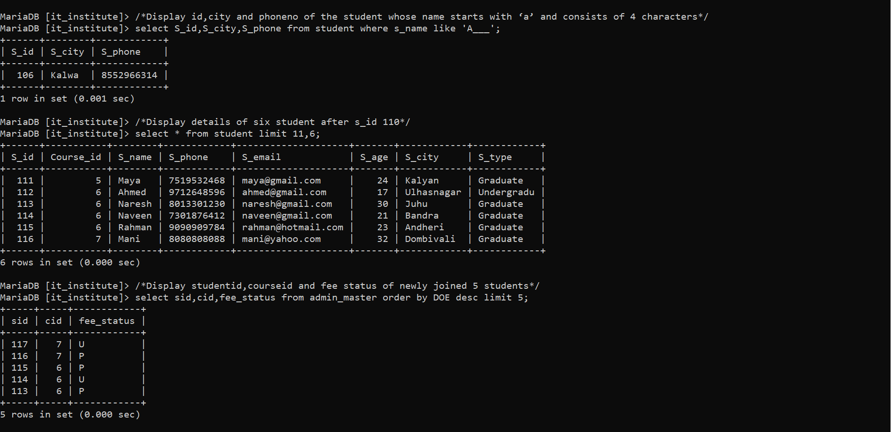**Select queries with String functions:**

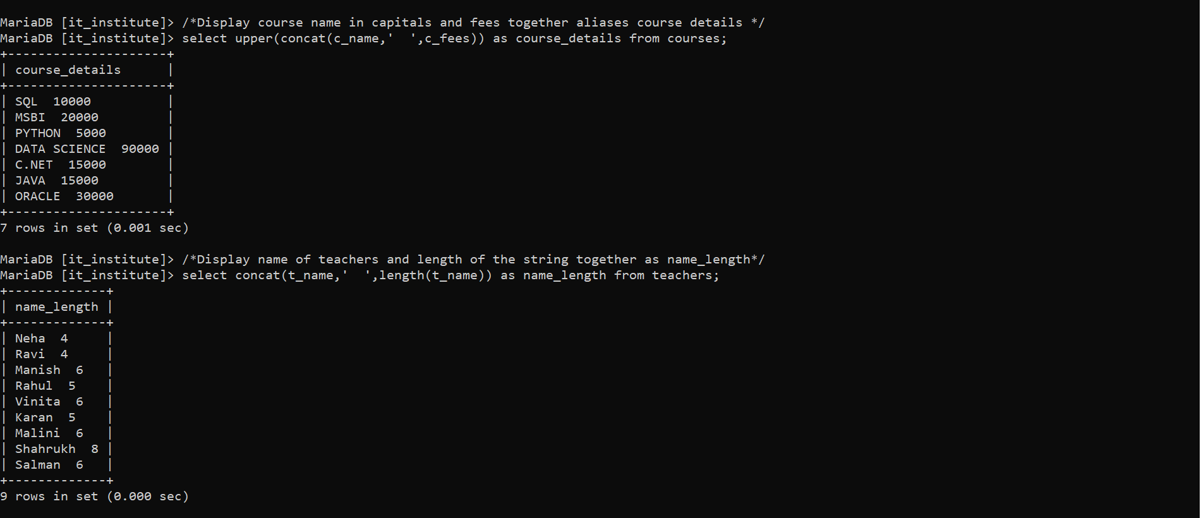

**Select queries with Date functions:**

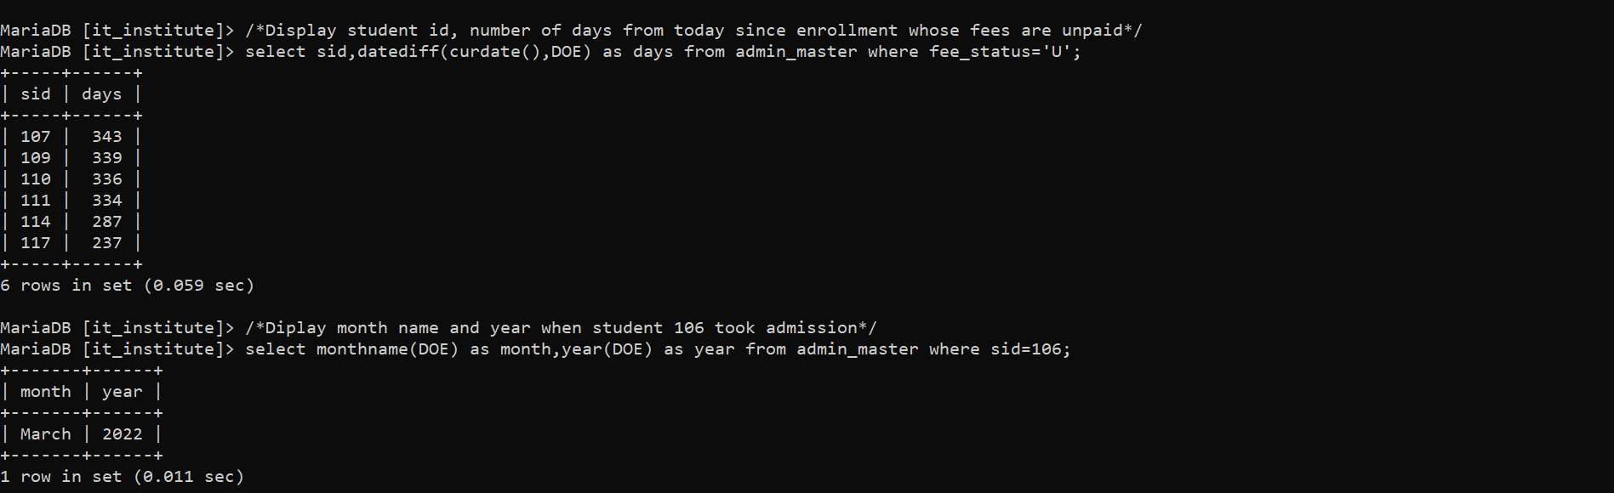

**Select queries with Aggregate functions:**

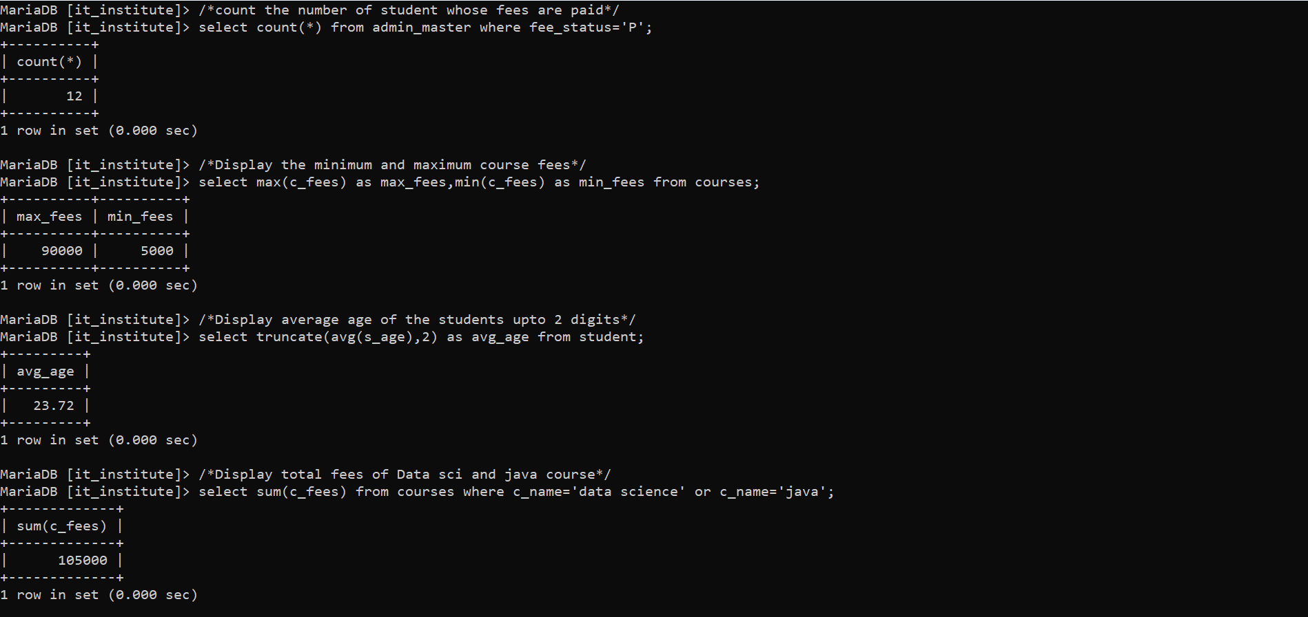

**Select queries with Group by and Having clause:**

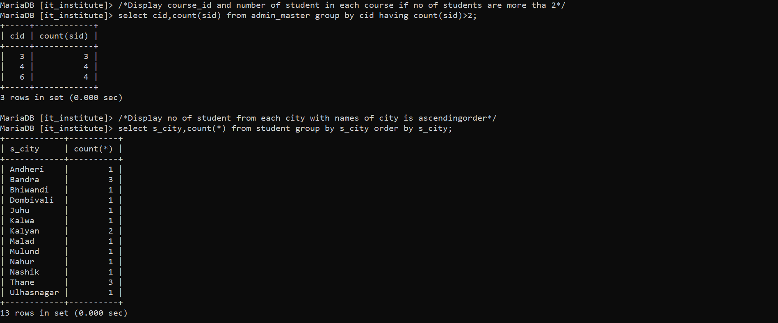**SUBQUERIES:**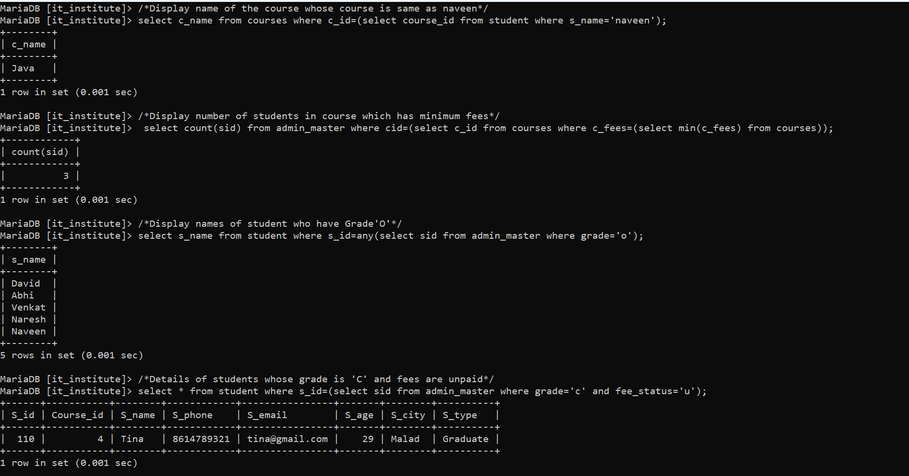

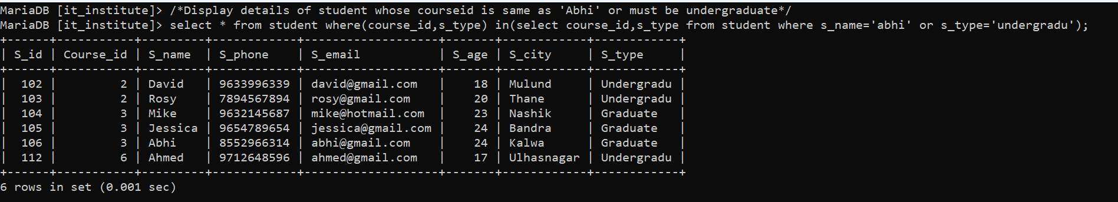**JOINS:**

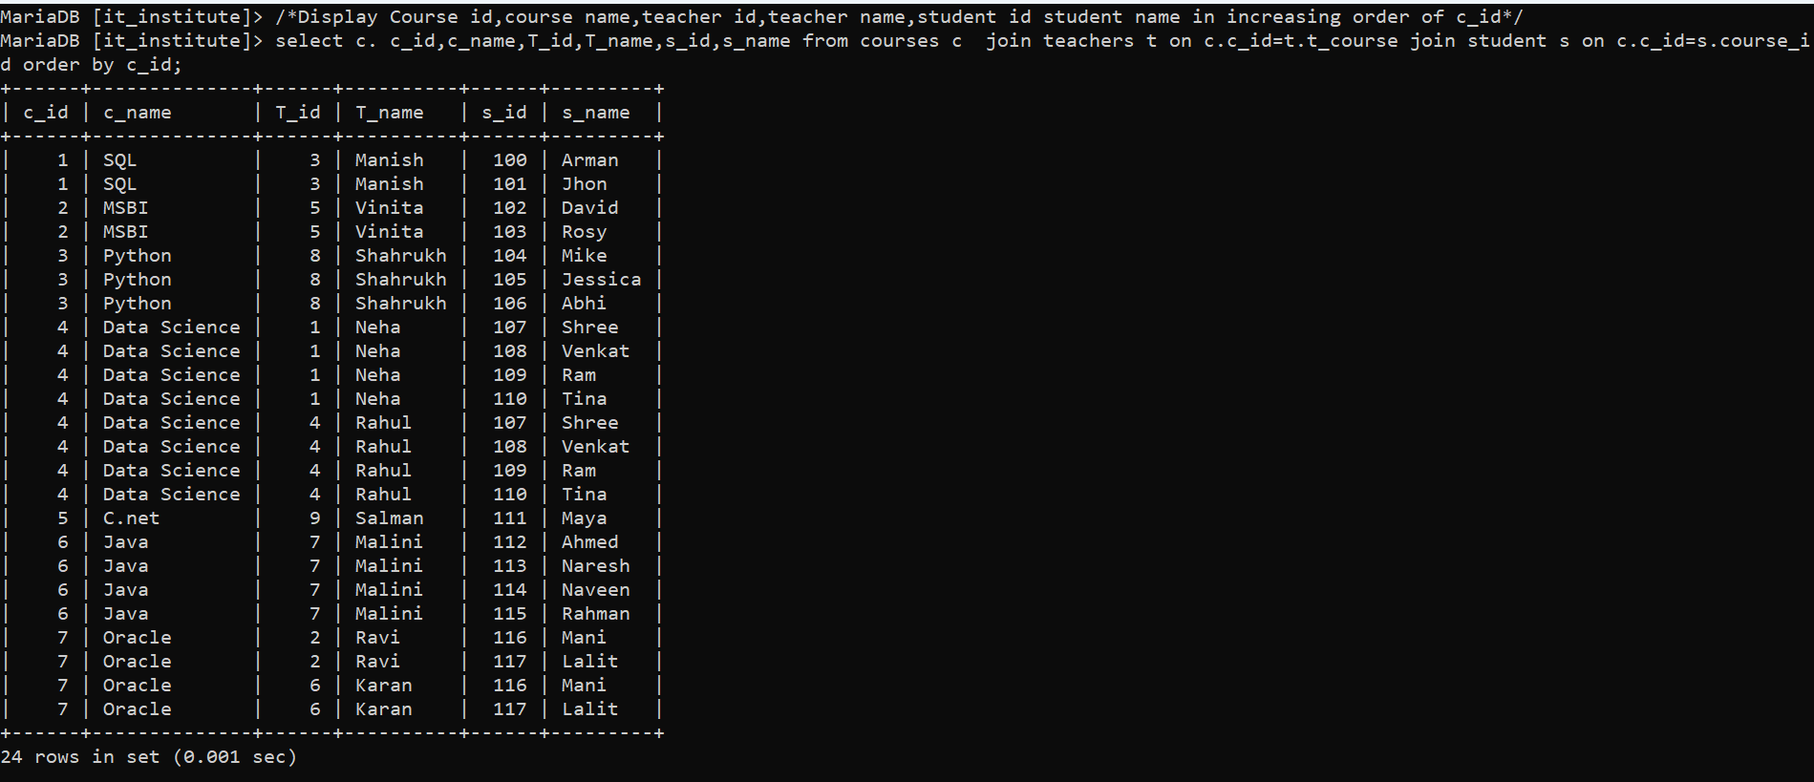

**VIEWS:**

**Create view-**

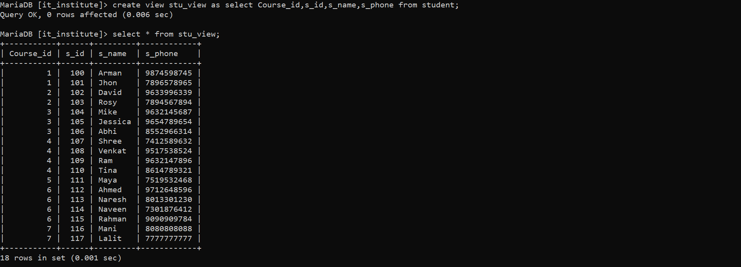

**INSERT into view:**

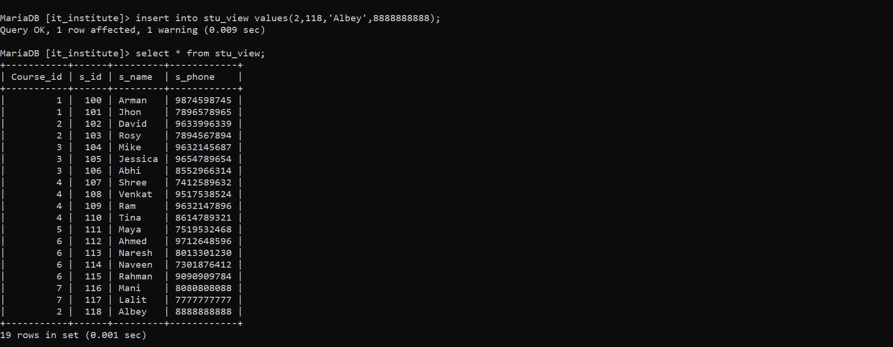

**Alter view:**

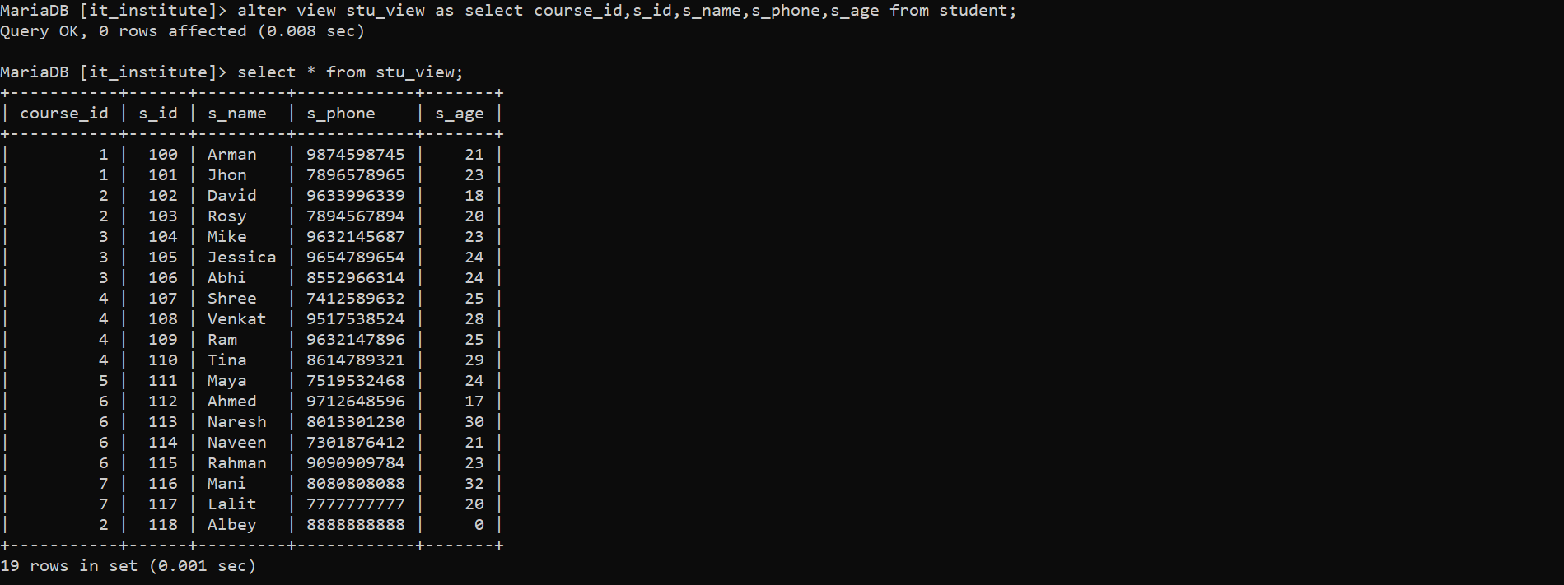

**Update view:**

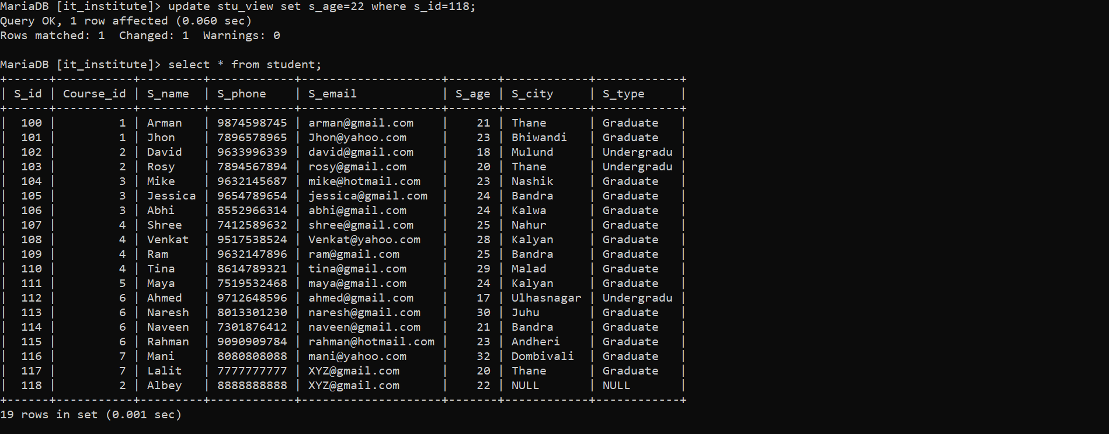

**Delete and Drop view:**

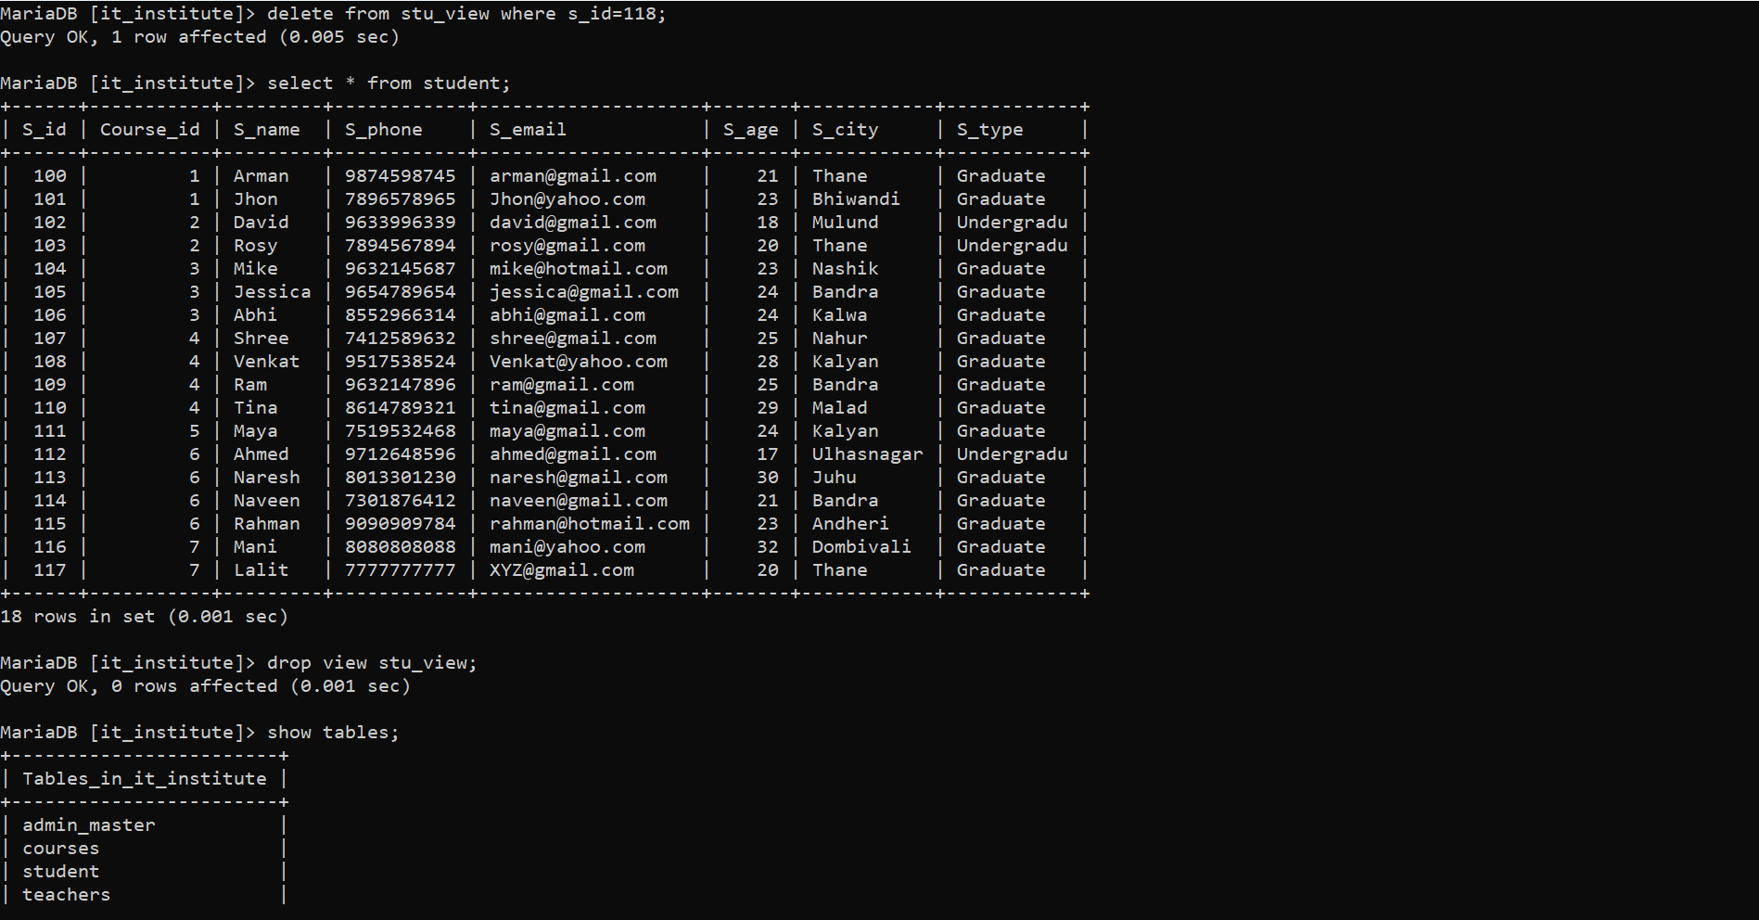

**Update using SUBQUERY:**

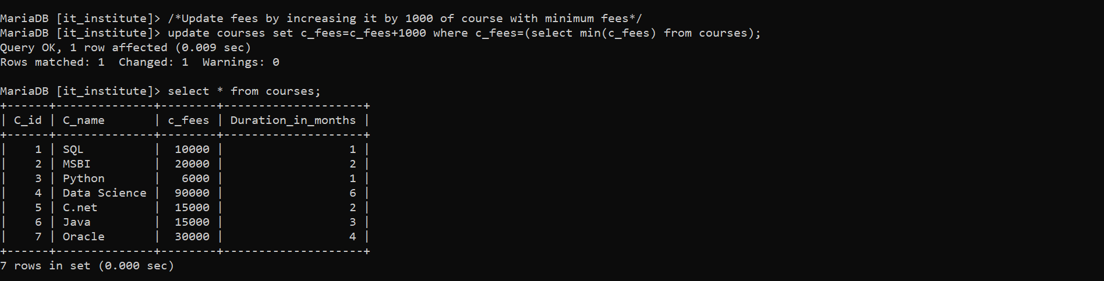

**Select with Distinct:**

